YEAR 11 GEOGRAPHY

SEMESTER ONE 2000

Name of Student:____________________________________

Time allowed for this paper:

Reading time before commencing work: 10 minutes

Working time for paper: 2.5 hours

Your Mark
Section A 20 Marks
Secton B 20 Marks
Section C
Part (a) 20 Marks
Part (b) 20 Marks
Part (c) 20 Marks
TOTAL MARK | %

INSTRUCTIONS TO CANDIDATES

This paper consists of Section A, B and C.

Section A – Multiple Choice and Section B – Short Answer are to be completed within the booklet in the spaces provided.

Section C – Extended Answers are to be written on lined paper.

ALL answers to Section C are to be written on lined paper. Answer only 1 questions from section A and B and use a new page for each answer. Section C is worth 60 marks.
SECTION A MULTIPLE CHOICE

Study the topographic map on page 4 of the broadsheet and circle the correct answer.

- The Grid Reference for the following whaling station is: (2 marks)

- 8715
- 159873
- 1587
- 873159

2. The contour interval of the map is: (1 mark)

- 10 metres
- 15 metres
- 20 metres
- 30 metres

3. The distance of the Albany highway from its intersection with the South coast highway to the Mt Barker railway station is closest to: (2 marks)

- 24 km
- 50 km
- 47 km
- 42 km

4. The flow of the Mill Brook GR775397 is generally: (1 mark)

- N.E
- S.E
- E
- S.W

- The difference in altitude between Wilgie Hill GR590250 and the homestead named Springfield GR574272 is closest to: (1 mark)

- 80 metres
- 100 metres
- 120 metres
- 60 metres

6. The latitude and longitude of Albany is: (1 mark)

- 35º02’ 117º52’
- 117º52’ 35º02’
- 35º52’ 117º02’
- 02º35’ 52º117’

7. Arrange the following coastal features in logical order of formation: (2 marks)

Sea cave (1) Stack (2) Arch (3) Headland (4)

- 1, 2, 3 and 4
- 3, 1, 4 and 2
- 2, 3, 4 and 1
- 4, 1, 3 and 2

- The removal of vegetation form a dune system through indiscriminate recreational use will lead to a: (1 mark)

- Wind tunnel
- Berm
- Blow out
- Dune scar

- ___________________ refers to the broken down rock, mineral grains and clay that have weathered from bedrock. (1 mark)

- Regolith
- Bedrock
- Lithosphere
- Asthenosphere

10. The solid rocky portion of the earth is called the: (1 mark)

- Hydrosphere
- Atmosphere
- Biosphere
- Lithosphere

11. In comparison with the rocks of the crust beneath the oceans, the rocks of the Earth’s crust that make up the continents are: (circle each alternative.) (2 marks)

(a) Lighter Heavier
(b) Thinner Thicker
(c) Younger Older
(d) Less varied More varied

12. In comparison with the summer beach profile the winter beach profile has: (3 marks)
(Circle each alternative)
(a) Spiller waves Plunging waves
(b) A bar A berm
(c) Relatively frequent waves Relatively infrequent waves
(d) The swash more powerful The backwash greater than the
than the backwash swash
(e) Deposition Erosion
(f) A wide gently sloping beach A short steep beach

- Look at the following statements and decide which are true, then from the following list choose the correct combination: (2 marks)

(a) Shield volcanoes form when magma and gas sprayed into the air form into pellets of ash which fall to build steep sided volcanoes.
(b) The asthenosphere is part of the mantle and it consists of hot, soft semi fluid rock.
(c) Seismographs are sensitive instruments that measure the rate of sea floor spreading.
- A sill is the hard volcanic rock formed inside the crater of a volcano.
- The islands of Hawaii have been formed over hot spots.
- Bedrock is the solid hard rock which has not yet been weathered.
- Rips are low velocity onshore currents.
- The name of the dune closest to the beach is called a primary dune.

(i) a, e, f, g (iii) b, f, g, i
(ii) c, g, h, i (iv) d, g, f, h

SECTION B – SHORT ANSWER

1. Using Plate theory account for the location of the worlds volcanoes. (3 marks)

_____________________________________________________________________________
_____________________________________________________________________________
_____________________________________________________________________________
_____________________________________________________________________________
_____________________________________________________________________________
_____________________________________________________________________________
_____________________________________________________________________________
_____________________________________________________________________________

- list two types of Mass Movement and explain each process. (4 marks)

Type 1:
_____________________________________________________________________________
_____________________________________________________________________________
_____________________________________________________________________________
_____________________________________________________________________________
_____________________________________________________________________________

Type 2:
_____________________________________________________________________________
_____________________________________________________________________________
_____________________________________________________________________________
_____________________________________________________________________________
_____________________________________________________________________________

STUDY THE TOPOGRAPHIC MAP ON PAGE 4 OF THE BROADSHEET

- Examine the stretch of road between Mt Barker GR616673 and the intersection of Chester Pass Road and the Mt Barker Porongurup Road GR877602. If you left Mt Barker and travelled east to the intersection, describe the major physical and cultural landscape features that you would view within 5 km on both sides of the road (the Landsat image may also help you). (4 marks)

Physical landscape features:
_____________________________________________________________________________
_____________________________________________________________________________
_____________________________________________________________________________
_____________________________________________________________________________
_____________________________________________________________________________

Cultural landscape features:
_____________________________________________________________________________
_____________________________________________________________________________
_____________________________________________________________________________
_____________________________________________________________________________
_____________________________________________________________________________

- Describe the site and situation of Albany. (Try to mention at least three relevant points for each). (3 marks)

Site
_____________________________________________________________________________
_____________________________________________________________________________
_____________________________________________________________________________
_____________________________________________________________________________
_____________________________________________________________________________

Situation
_____________________________________________________________________________
_____________________________________________________________________________
_____________________________________________________________________________
_____________________________________________________________________________
_____________________________________________________________________________

STUDY THE REMOTE SENSED IMAGE ON PAGE 1 OF THE BROADSHEET

5. Calculate the distance across the top of the image along the line 65. (1 mark)

_____________________________________________________________________________

6. Calculate the distance from the Western edge of the Porongurup’s GR348485 to the town of Mt Barker GR323489. (1 mark)

_____________________________________________________________________________

STUDY THE AERIAL PHOT ON PAGE 3 OF THE BROADSHEET

- Suggest the most likely major land use found at the following locations of the aerial photo.
(2 marks)

- 460900 _________________________________________________________________
- 477817_________________________________________________________________
- 507895_________________________________________________________________
- 518795_________________________________________________________________

8. With the aid of the topographic map identify the nearest eastings and northings which define the boundaries of the area covered by the photo and mark them on the diagram. (1 mark)

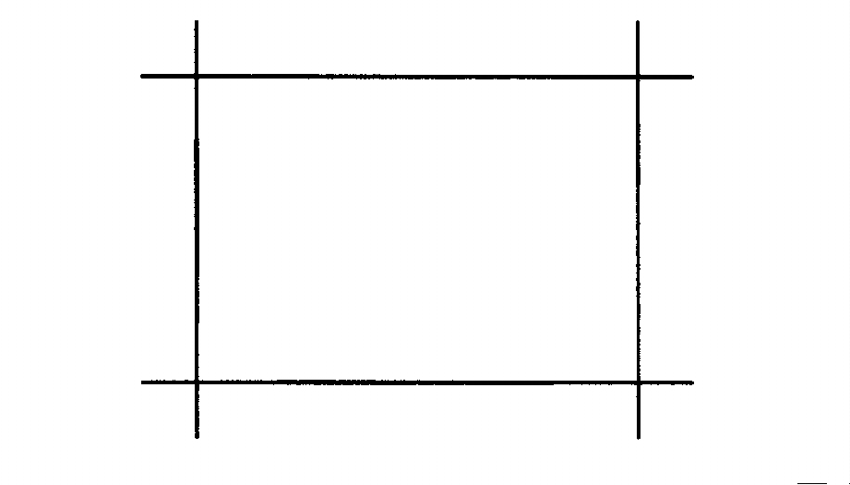

9. Five centimetres on the photo would be eqivalent to how many metres on the ground? (1 mark)

_____________________________________________________________________________
SECTION C – EXTENDED ANSWERS

Answer two questions from the following four (One from Part A and One from Part B)

PART A

1. (a) Define the term gradation and describe the five gradational processes. (6 marks)
- Using diagrams to help you, explain the process of chemical and physical weathering of rock. (8 marks)
- Explain how the devils marbles in the Northern Territory were created. (6 marks)

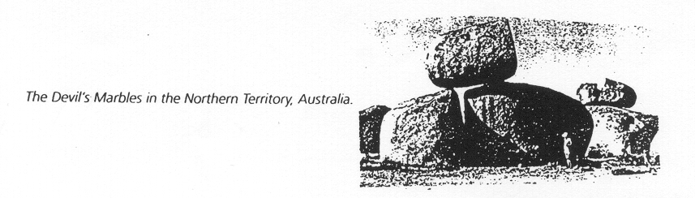

2. (a) Explain the four methods by which waves erode the coast. (8 marks)
(b) Using the diagrams, explain the process of longshore drift. (4 marks)
(c) List the features created by coastal deposition. (2 marks)
(d) How can humans reduce their impact on the coastline? (6 marks)

PART B

3. (a) Using a diagram to help you, explain the worlds heat budget. (6 marks)
(b) Explain the three ways in which the earth transfers heat to the atmosphere. (6 marks)
(c) Describe the ways in which the worlds insolation can vary from place to place and time to time. (8 marks)

4. (a) Explain how high and low pressure areas are created in the atmosphere. (6 marks)
- Using land and sea breezes as an example, explain how the difference in air pressure between areas causes winds to blow across the planets surface. (6 marks)
- With reference to the latitudinal movement of the worlds pressure belts, account for the difference in Perth’s summer and winter climate. (8 marks)
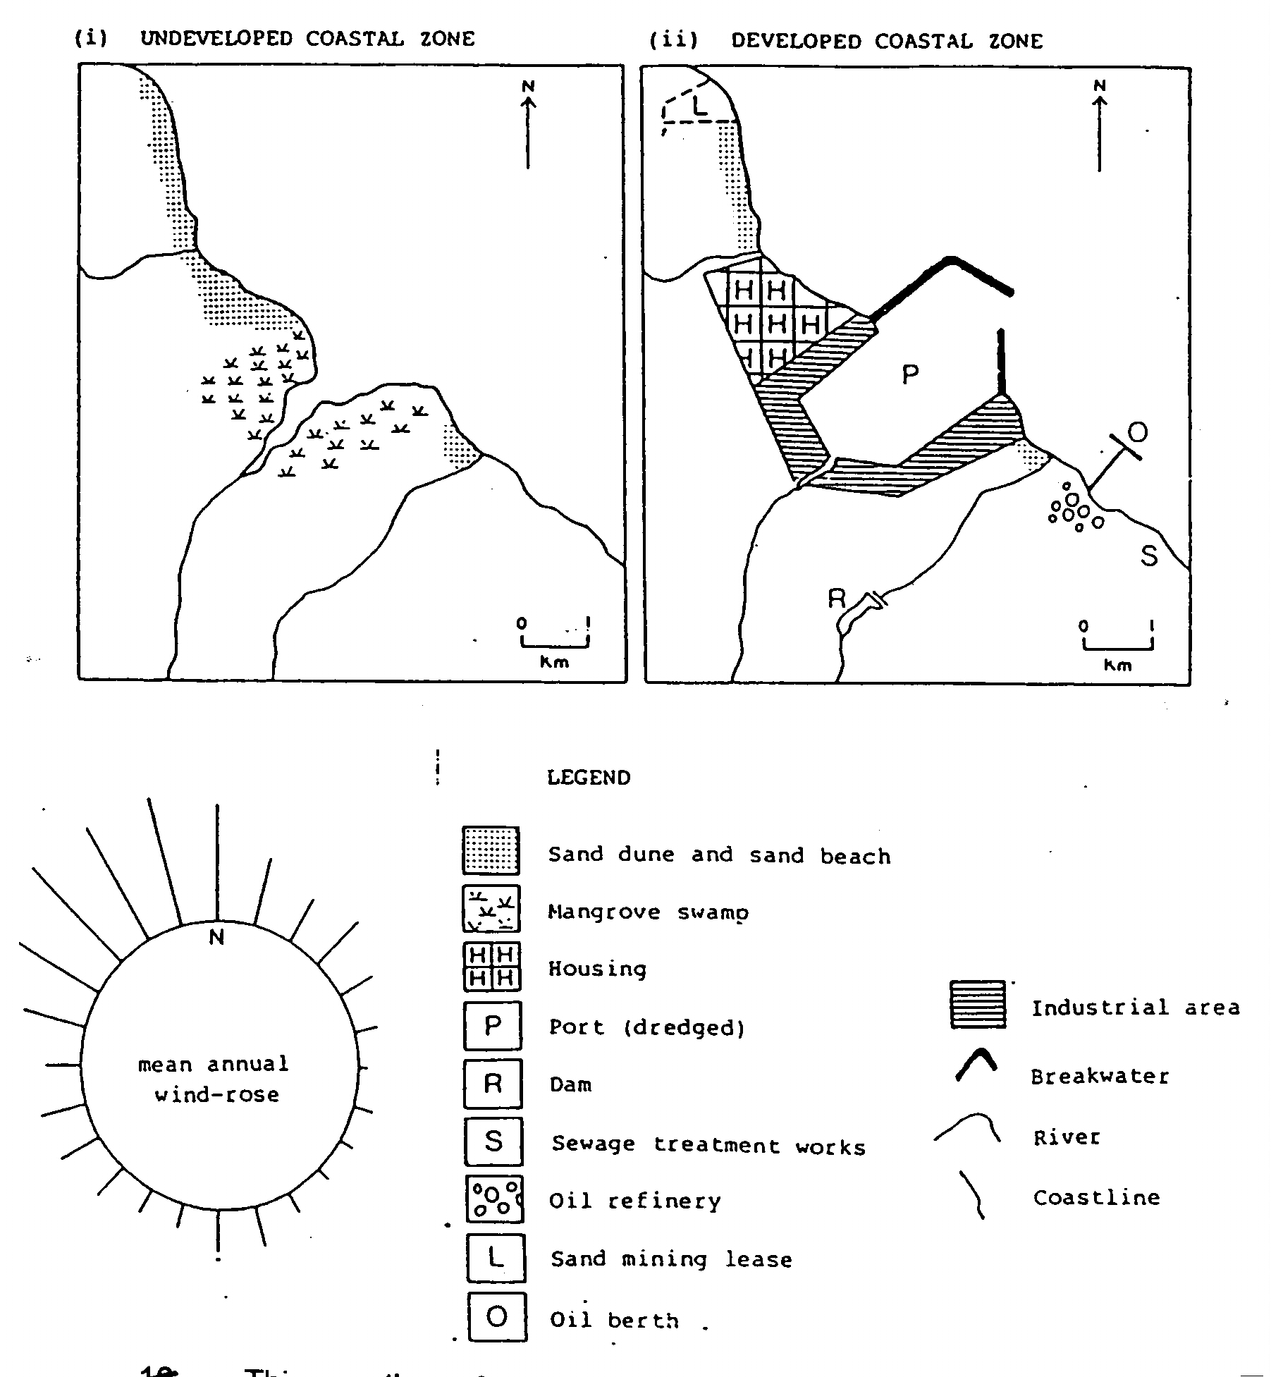

PART C

This question refers to the two sketch maps and diagrams above. Using all the evidence given answer these questions.

- Describe and explain the probably directions of the predominant waves, longshore drift and sand dune movements. (6 marks)
- Describe and explain the reasons for the siting of the breakwater, sewage treatment works and the oil berth. (6 marks)
- Describe and explain the possible effects that this development will have on the areas physical processes over time. (8 marks)

